Journal of Sound and Vibration 455 (2019)136-149 ©2019

Audible thumping from wind farms can travel up to 3.5 km

Significance
Technically, wind energy is a form of solar energy. Consequently, it is renewable and can be used to generate electricity; this knowledge has been exploited greatly, particularly in the past decade where many wind farms have been installed in different regions worldwide. Wind farms are comprised of numerous large wind turbines that rotate, and the generated motion is transferred to a generator that in turn converts the kinetic energy to electric energy. So far, the process seems flawless; unfortunately, reports from residents of areas surrounding the wind farm have raised complaints regarding noise pollution generated by the turbines. More specifically, the motion of the large blades and mechanical parts of the turbines generate noise that has been reported to cause annoyance, sleep disturbance and consequently adverse health effects. Therefore, to ensure that residents living near wind farms are not subjected to excessive noise-related disturbance, it is important to identify potentially disturbing wind farm noise components. Moreover, suitable methods for quantifying these components are required. Acceptable threshold levels also need to be defined to determine the prevalence of potential noise disturbance.
Literature has it that the presence of amplitude modulation (AM) in wind farm noise is the result of annoyance. Presently, an extensive review of existing methods for AM detection and quantification can be found in various studies. Of particular interest is the IOA ‘reference method’ that incorporates various concepts, can be automated thus allowing analysis over long time periods, and is robust to background noise contamination, thus reducing the instances of false positives.
Overall, it is important to determine how often AM is present at residential locations near a wind farm. In this view, Australian researchers from the Flinders University: Dr. Kristy Hansen, Phuc Nguyen, Dr. Branko Zajamšek, Prof. Peter Catcheside, in collaboration with Prof. Colin Hansen at The University of Adelaide studied the prevalence and characteristics of wind farm AM of a certain windfarm in Australia. Their goal was to determine how often AM occurred at various distances from the wind farm and to assess the suitability of the IOA ‘reference method’ for detecting low-frequency AM of a tone that is generated by wind turbines. Their research work is currently published in Journal of Sound and Vibration.
Their approach involved outdoor measurements for a total of 64 days at 9 different residences located between 1 and 9 km from the nearest wind turbine of a South Australian wind farm, which at the time of measurements was made up of 37 operational turbines, each with a rated power of 3 MW. The motivation for their analysis was to investigate the prevalence of a low-frequency ‘thumping’ or ‘rumbling’ noise that had been mentioned in complaints from residents.
The authors reported that an audible indoor low-frequency tone was amplitude modulated at the blade-pass frequency for 20% of the time up to a distance of 2.4 km. In addition, they found that the audible AM occurred for a similar percentage of time between wind farm percentage power capacities of 40 and 85%, indicating that it was important that the AM analysis should not restricted to high power output conditions only.
In summary, the study investigated the prevalence and characteristics of wind farm AM at 9 different residences located near a South Australian wind farm. Their work showed that, despite the number of AM events being recorded to reduce with distance, audible indoor AM still occurred for 16% of the time at a distance of 3.5 km. At night-time, audible AM occurred indoors at residences located as far as 3.5 km from the wind farm for up to 22% of the time. In a statement to Advances in Engineering, Dr. Kristy Hansen pointed out that the adopted approach was successful, although more research was needed to quantify the annoyance and sleep disturbance potential of the recorded type of tonal AM.
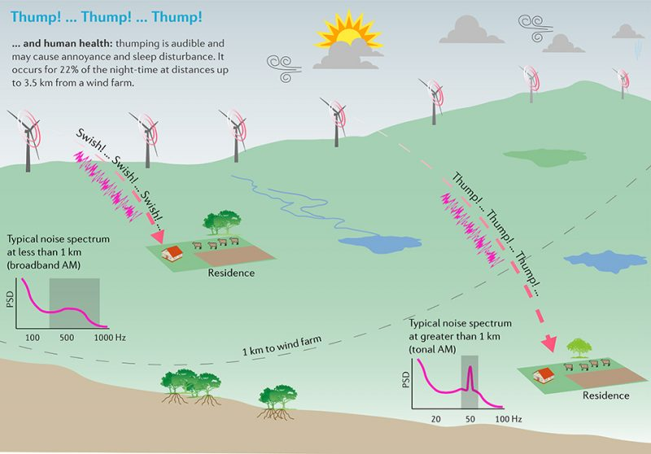

About the author
Kristy Hansen is currently a Senior Research Fellow at Flinders University. Since graduating with a PhD in aeroacoustics in 2012, she has focused her research on wind farm noise and its effects on people. In 2016, she was part of the team awarded a 5-year grant by the National Health and Medical Research Council on sleep disturbance by wind farm noise. In 2017 she was awarded a Discovery Early Career Research Award by the Australian Research Council for her project on annoying characteristics of wind turbine noise. She received the Sir James Lighthill Award for best student paper at the International Congress on Sound and Vibration in 2012 and the Vice Chancellor’s Award for Early Career Researchers from Flinders University in 2018. She has over 30 publications in journals and conference proceedings and she is a co-author of the book, “Wind Farm Noise”, published in 2017.

About the author
Duc Phuc Nguyen is currently a PhD student at Flinders University, Australia. He is a former Australia Awards scholar and was the recipient of the prestigious Chancellor’s letter of commendation during his Master’s degree at Flinders University.
His research work involves quantification and characterisation of wind farm noise based on long-term measurements of acoustical and meteorological data. The results of his study are expected to fill the current gap in knowledge related to the quantification of wind farm noise characteristics and their prevalence, which is expected to improve quality of life for residents living near wind farms and to encourage a sustainable development.

About the author
Branko Zajamsek is currently a Research Associate at the Adelaide Institute for Sleep Health, Australia. He graduated with a PhD in experimental aeroacoustics in 2017 at the University of New South Wales in Sydney, during which he was studying aeroacoustic noise sources on a wind turbine. His current research is focused on characterisation and modeling of wind farm noise and effects of environmental noise on sleep. He has over 30 publications in top-tier acoustic journals and conference proceedings.

About the author
Peter Catcheside is a Professor in the College of Medicine, Flinders University. He completed his PhD in exercise physiology and worked in a range of exercise physiology, respiratory and sleep scientific support roles before joining the Adelaide Institute for Sleep Health (AISH), where he now leads a multi-disciplinary team of sleep and respiratory researchers. His work is mainly focused on understanding physiological processes underpinning respiratory and cardiovascular disturbances during sleep towards direct translation into improved measurements, diagnostic and treatment approaches for a range of sleep and breathing problems. He is currently involved in a range of clinical trials and leading physiology studies to improve breathing effort assessment in sleep and during mechanical ventilation and a large 5-year project investigating environmental noise effects on sleep.

About the author
Colin Hansen is currently an Emeritus Professor at The University of Adelaide. He has been working on wind farm noise and its effects on adjacent communities since 2010. He is an Honorary Fellow of the International Institute of Acoustics and Vibration, a recipient of the UK Institute of Acoustics Rayleigh Medal, the Engineers Australia A.G.M. Michell medal and the Acoustical Society of America Rossing Prize.
He has over 300 publications in scientific journals and conference proceedings, is on the editorial Boards of Applied Acoustics and the International Journal of Acoustics and Vibration and has authored or co-authored more than a dozen books on acoustics and noise control, including one on wind farm noise.

Reference
Kristy L. Hansen, Phuc Nguyen, Branko Zajamšek, Peter Catcheside, Colin H. Hansen. Prevalence of wind farm amplitude modulation at long-range residential locations. Journal of Sound and Vibration, volume 455 (2019) page 136–149.
Go To Journal of Sound and Vibration

